# 

**SECP1513 TECHNOLOGY AND INFORMATION SYSTEM**

**SEMESTER 1 2025/2026**

**SECTION 04 GROUP 8**

**TITLE: UTM SMART MENTAL HEALTH**

**GROUP MEMBERS:**

|  |  |  |
| --- | --- | --- |
| **NO** | **NAME** | **MATRIC NO** |
| **1.** | **BRANSON KOH MING XUAN** | **A25CS0199** |
| **2.** | **CHA XIN YUAN** | **A25CS0200** |
| **3.** | **ANG LE SHAN** | **A25CS0193** |
| **4.** | **ERIC TAN ZHI EN** | **A25CS0058** |

**LECTURER: DR SHAFAATUNNUR BINTI HASAN**

**CONTENTS**

1.0 Introduction 1

2.0 The Overview of the Design Thinking Process 1

3.0 Detailed Descriptions: Problem, Solution and Team Working 1

3.1 Problem 2

3.2 Solution 2

3.3 Team Working 2

4.0 Design Thinking Assessment Points 3

4.1 Assessment At The End of the Project Demonstration 3

4.2 Assessment During The Transition Between Design Thinking Phases 3

5.0 Design Thinking Evidence 4

5.1 Empathy Phase 4

5.2 Define Phase 6

5.3 Ideate Phase 6

5.4 Prototype Phase 8

5.5 Test Phase 12

6.0 Reflection 14

# 1.0 Introduction

At Universiti Teknologi Malaysia (UTM), students are required to adapt to their coursework, tight deadlines, and learning environment, which can significantly affect their mental health.

To overcome these, UTM Smart Mental Health aims to encourage awareness and provide easy access and understanding support among students. The application is centered on mental wellness, with functions such as mood checks, counseling session bookings, visual stress indicators, support resources, and anonymous support requests.

# 2.0 The Overview of the Design Thinking Process

To develop a UTM Smart Mental Health system, we used five simple steps called “Design Thinking”. Instead of building the system by guessing the students' needs, we spend our time understanding the real-life problems faced by students in UTM by surveying the students and we looked at the reasons why UTM students find it difficult to seek mental health support. Finally, we made sure our website truly helps students to solve their mental health issues by defining the problems faced by students, coming up with ideas to build a system, building a design and undergoing the testing process.

# 3.0 Detailed Descriptions: Problem, Solution and Team Working

## 3.1 Problem

UTM students face high academic stress and emotional pressure but have limited access to adequate mental health support services. This situation makes it difficult to manage their emotional well-being effectively.

## 3.2 Solution

To provide students with easy access to mental health support through a digital platform**,** theUTM Smart Mental Health system was designed. The system allows students to book a counseling session, daily mood check-in, access mental health resources, and request anonymous support. This helps students become more aware of their mental health and reduces barriers to seeking help.

## 3.3 Team Working

Each team member contributed by handling different tasks such as collecting survey data, designing the prototype, preparing documentation, and working on the presentation. We held weekly discussions to share progress, exchange ideas, and solve any problems together.

# 

# 4.0 Design Thinking Assessment Points

The assessment of the design thinking process was conducted at the end of the project demonstration and during the transition between design thinking phases to ensure continuous improvement.

## 4.1 Assessment At The End of the Project Demonstration

When the complete prototype was presented, we evaluated the alignment between the identified user needs and the proposed solutions, as well as the usability of the interface of the prototype. We also evaluated the effectiveness of specific features that were proposed in the UTM Smart Mental Health system to ensure it addressed mental health challenges.

## 4.2 Assessment During The Transition Between Design Thinking Phases

During the transition from empathy to the define phase, we evaluated the survey insights because survey insights would reflect the users' needs accurately. As we transitioned from the Define to the Ideate phase, the problem statement's clarity was evaluated. Subsequently, moving from Ideate to Prototype, we carefully considered both the feasibility and empathy value of the proposed solutions. Last but not least, during the transition from prototype to test phase, we assessed the technical flow and consistency of the system so that the testing session could run smoothly for the users.

# 5.0 Design Thinking Evidence

## 5.1 Empathy Phase

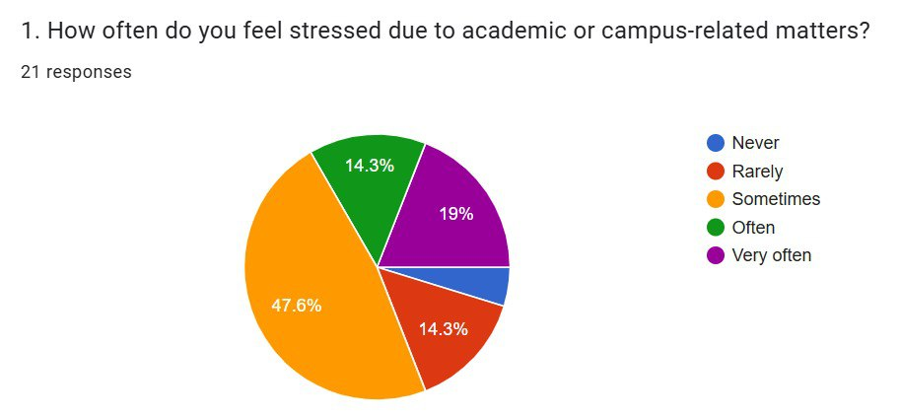

Based on Question 1 on the survey, we found that 47.6% of the respondents sometimes feel stressed due to academic or campus-related matters, 19% of the respondents very often feel stressed, 14.3% of respondents often or rarely feel stressed, and 4.8% of the respondents never feel stressed.

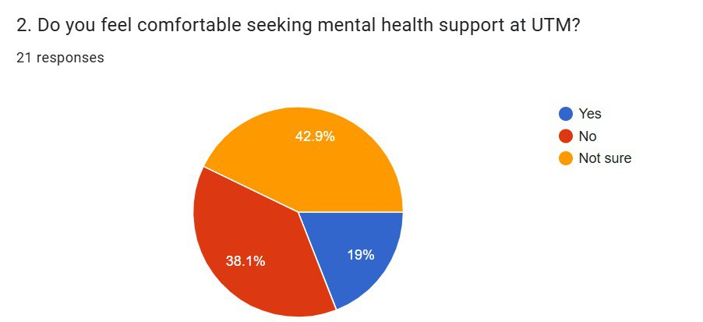

Based on Question 2 of the survey, we found that 38.1% of the respondents do not feel

comfortable seeking mental health support at UTM. A significant portion of respondents, specifically 42.9%, are uncertain about their comfort level in seeking mental health support at UTM, and a minority of the respondents, which is 19% feel comfortable seeking mental health support at UTM.

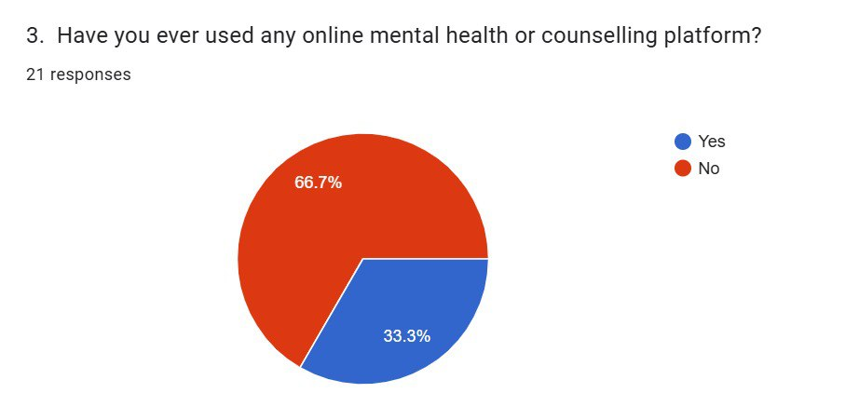

Based on question 3, there is a majority of respondents who is 66.7% never used any online mental health or counselling platform, while there is 33.3% of respondents used an online mental health or counselling platform.

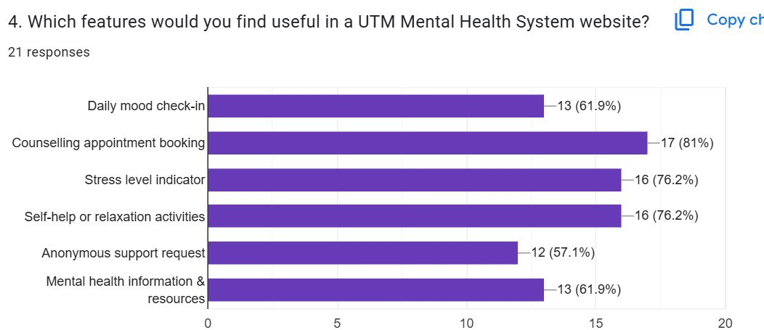

Based on question 4, we found that 17 respondents agree that counselling appointment booking is useful on the UTM Mental Health System website, while there is are equal number of respondents which are 16 respondents who agree that stress level indicator and self-help or relaxation activities are useful on the UTM Mental Health System website. At the same time, 13 respondents find that daily mood check-in and mental health information & resources features are useful in a UTM Mental Health System website. Lastly, 12 respondents find the anonymous support request feature is useful on the UTM Mental Health System website.

## 5.2 Define Phase

In the define phase, the core challenge was identified through the synthesis of the data survey. A crucial finding is the feeling of discomfort and lack of digital accessibility, evidenced by the fact that 81% of students are either uncomfortable or uncertain about seeking help at UTM. Consequently, for a "Future Digital Campus," the solution must directly address this gap. It must incorporate features specifically requested by students, such as an appointment booking system and stress indicators in the UTM Smart Mental Health system, within a platform that provides a sense of privacy that does not exist in traditional face-to-face counselling sessions.

## 5.3 Ideate Phase

During the ideate phase, we brainstormed many ideas for a "Future Digital Campus." We decided to make anonymous message boards to allow users to communicate with the counsellor privately. We strategically chose to put the stress tracker and mood check-in at the main page rather than clinical appointment tools, aiming to make it feel like a daily wellness companion rather than a hospital portal, which allow the counsellor understand the feeling of the users better before the counselling session.

## 

## 5.4 Prototype Phase

In the prototype phase, we first built a login interface that allows users to log in as a UTM student or a UTM staff member. Next, users will be brought to an interface that allows them to determine their feelings and mood for the day, and next to it will be a mood trend graph that displays their mood change for the day. In the second part, there is a mental health wellbeing assessment that consists of 10 questions to get personalized mental health insights . After taking the test, it will analyse and display the user's mental health condition and give some advice to the users according to their mental health condition. The third part of the interface, it allows users to book a counselling session, and it will display the information of the upcoming appointment on the right side to remind users of their counselling session. For the fourth part, it will give a list of suggestions for activities that help users relieve their tension with a timer. Lastly, the support part allows users to get support from a counsellor anonymously, and there is an emergency number if users face a critical mental health condition.

## 

|  |
| --- |
|  |

## 

|  |
| --- |
|  |
|  |

## 

## 

|  |
| --- |
|  |
|  |

## 

|  |
| --- |
|  |
|  |

## 

|  |
| --- |
|  |
|  |

## 5.5 Test Phase

We showed our design to some UTM students and staff to see if it addressed the problem mentioned in the survey and got feedback from the users to ensure that our prototype is user-friendly and meets the users' requirements. As a result, most of the users felt that the combination of private booking and visual stress tracking solved the main reasons they previously avoided seeking mental health support.

# 6.0 Reflection

**Cha Xin Yuan**

My goal is to become a professional who can design digital solutions for real-life problems. This design thinking project has inspired me about the importance of user needs and user-centered design in UTM mental health care support. This showed that technology is not all about technical skills but more about user needs and experiences. To improve my potential in the industry, I plan to improve my design skills, communication, and teamwork abilities.

**Branson Koh Ming Xuan**

Throughout this course, I hope that I can become a skilled professional who truly helps people in their daily lives by building some creative solutions. This design thinking project has impacted my goal by knowing that creating a successful software is not just about writing code, but understanding the users’ needs and feelings before creating the solution. I planned to focus on improving social communication skills and always acquiring new knowledge to maximize my potential in the industry.

**Ang Le Shan**

My goal with regard to my program is to enhance my cybersecurity skills and programming techniques. This design thinking helps me clearly understand the processes, such as prototyping to build a new system to solve existing problems. In order to improve my potential in the industry, I will continuously learn the latest technology and skills via GitHub and online learning platforms.

**Eric Tan Zhi En**My goal is to become a highly skilled computer science professional, capable of effectively using technology to solve real-world problems. This design thinking helps me to enhance my potential in the industry. I plan to strengthen my problem-solving abilities, improve my technical knowledge, and enhance my communication and teamwork skills.